Beverly Minor Hockey Association COVID-19 Information for Visiting Teams
 | Entry into the Beverly arena is allowed 30 minutes prior to game time
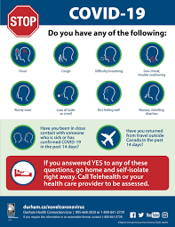 | Complete COVID-19 Self- Screening prior to entering the arena
 | Contract Tracing information requested for each individual entering the arena (name/phone number)

Mandatory masks to worn upon entering the arena.

Mandatory masks to be worn by all players and coaches when not on the ice.
Update | Effective December 20th - Everyone 12 years & older must show vaccine verification and ID upon entry.  (including players, bench staff)  Effective January 4th – Vaccine verification can only be provided by QR code.  Effective January 11th - All medical exemptions must be provided through a QR code provided by public health.  (printed QR codes can be scanned)
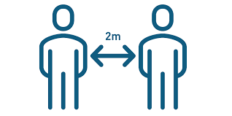 | Maintain Social Distance  Capacity Limits in Place  (Limit spectator numbers to avoid being turned away if capacity limits are exceeded)

RESPECT OUR ASSOCIATION, RESPECT OUR FACILITY

Understand that any irresponsible or disrespectful behavior in any club facility and/or toward any Coaches, Officials, players, or parents whether before, during or after a game or practice is inappropriate and will not be tolerate.

